STATION 1:Inertia Tower

Materials

1. Solo Cups
2. Index cards
3. Ribbon

**Procedures**

1. Stack 4 cups on top of each other with index cards places in-between them.
2. A friction force will be applied to the cup when we pull the index cards out from the tower one at a time, observing the movement of the cups.
3. Restack your tower and try and pull out all the cards at the same time. Observe the movement of the cups.

**NOTE: If the cup topples over we can equate that to movement. Inertia is an objects ability to resist motion so we will measure the amount of inertia an object has by the amount of movement that is displayed when the block is removed.**

**Example:**

**Cup topples over = little inertia**

**Cup stays on the tower= Large amount of inertia**

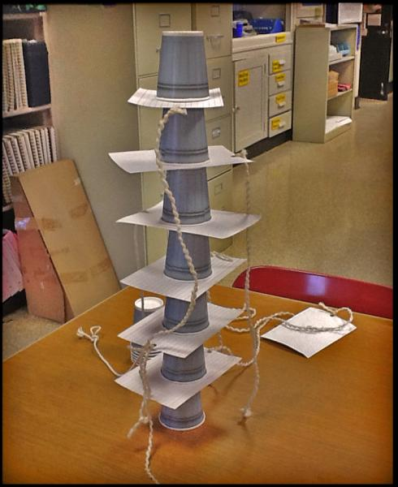

STATION 2: CRASH!

**Materials:**

2 textbooks

Ruler taped down to act as a ramp

Matchbox car

Snowman made of clay

Pencil taped to the table to act as a stopper

**Procedure**: Steps 1-3 are done for you. Read them and notice how this station is set up. Then do steps 4-9.

1. Raise one end of the ramp and place it on one of the books.

2. Tape the other end of the ramp to a table.

3. Tape the pencil perpendicular to the end of the ramp. Make sure to leave two and a half car lengths from the end of the ramp to the pencil. (Not sure what this looks like? Check out the picture)

4. Gently sit the snowman on the hood of the toy car. You want the clay figure to fall off the car easily, so do not press the clay against the car.

5. Position the car with its clay figure at the top of the raised ramp.

6. Release the car and allow it to roll down the ramp and collide (crash!) into the pencil.

7. Use the ruler to measure (in cm) how far the clay figure falls (not roils-just the initial fall) from the car.

8. Repeat the procedure at least three times before raising the ramp by adding a second book.

9. Record the distance traveled by the clay figure in the chart.



STATION 3: PLOP!

**Materials:**

Chair

5-6 textbooks

meterstick

**Procedure:**

1. Stack the books on the edge of the chair’s seat.

2. Push the chair forward about 1 meter and then quickly stop the chair.

3. Record with a meter stick how far the books fall. (measure from the front of the chair to the closest part of the book)

4. Repeat the procedure three times and record the results

in the table on your lab sheet.

5. Try pushing the chair faster. Measure how far the books fall. Do the books fall father?



STATION 4:Quarter Catch!

**Materials** = 1-4 quarters

**Procedure** = *Practice this first to determine how many quarters you are comfortable using*

1. Bend your elbow and place your hand at your ear, so that your forearm is perpendicular to your face.
2. Stack the quarter(s) on the flat portion of your elbow.
3. Throw your arm forward slowly and try to catch the coins with the same hand.
4. Repeat, this time moving your arm quickly enough to catch the coins.
5. Compare the results from the slow and fast trial.
6. Explain how this relates to Newton's First Law.

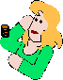

STATION 5: **Magicians Trick**

Materials:

* Sheet or tablecloth
* Table
* Heavy, non-breakable object (textbooks work great)

Procedure:

1. Place a cloth on the table.
2. Place the book on the cloth. Initially rest the book about 1-2 feet from the edge of the tablecloth.
3. Quickly pull the cloth out from under the book. Be sure to pull the cloth quickly (think of a snapping motion) and slightly down on the cloth. Can you pull the cloth out from under the book with minimal disturbance to the book?
4. Practice makes perfect! This trick requires a little skill and a little practice.

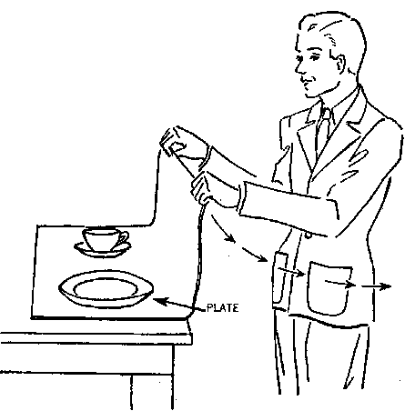

STATION 6: Egg Drop

**Materials**

* Cardboard tube
* Pie pan
* Ping Pong Ball/Golf Ball
* Water
* A large drinking glass

**Procedure**

1. Fill the large drinking glass about three-quarters full with water.
2. Center a pie pan on top of the glass.
3. Place the cardboard tube on the pie plate, positioning it directly over the water.
4. Carefully set the ball on top of the cardboard tube.
5. With your writing hand, smack the edge of the pie pan horizontally. Don't swing up, and don't swing down! It’s important that you hit the pie pan horizontally and use a pretty solid hit, so plan on chasing the plate and tube.
6. Watch the ball plop nicely into the water.

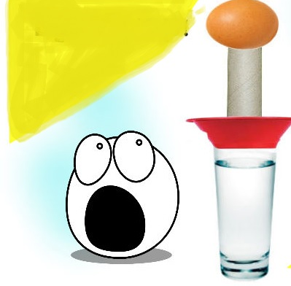

STATION 7: Balancing Bottles

**Materials**

2 water bottles filled with water

1 playing card

**Procedure**

1. Place the bottle containing water on the table.

2. Place the note card on top of this bottle.

3. Place the second bottle mouth down on top of the card and first bottle.

4. Line the two bottle’s opening up exactly on one top of the other.

5. Remove the note card without disturbing either bottle.

